

Jenkins Backup/Restore

|  |  |
| --- | --- |
| **Author** |  |
| **Approved By** |  |
| **Application Version** |  |
| **Date of Issue** |  |
| **Release Note Number** |  |

|  |  |  |  |  |
| --- | --- | --- | --- | --- |
| **Document Control Section** | | | | |
|  | | | | |
| **Revision History:** | | | | |
| **Document version** | **Pages** | **Action** | **Date of revision** | **By** |
|  |  |  |  |  |
|  |  |  |  |  |
|  |  |  |  |  |
|  |  |  |  |  |
|  |  |  |  |  |
|  | | | | |

Table of Content

1.0 Confidentiality / Legal notification 3

2.0 Introduction 4

3.0 JeNkins backup procedure 3

4.0 JENKINS Restore procedure 4

1. Confidentiality / Legal notification

Confidential. Copyright © AI Enterprise., 2018. All rights reserved. This document, including the information contained

herein, is restricted, confidential and proprietary to AI Enterprise, and is to be used only by and disclosed only to those

within AI Enterprise with a need-to-know. DO NOT COPY OR FORWARD INTERNALLY OR RELEASE outside AI Enterprise

without authorization in writing by a Sr. Vice President, Principal, or Director-level manager or a direct designee

thereof who has responsibility for the information contained herein.

1. Introduction

This document describes about How to configure Jenkins backup and restore procedure the same backup in the new Jenkins server.

Jenkins is an open source automation tool written in Java with plugins built for Continuous Integration purpose. Jenkins is used to build and test your software projects continuously making it easier for developers to integrate changes to the project and making it easier for users to obtain a fresh build. It also allows you to continuously deliver your software by integrating with many testing and deployment technologies.

With Jenkins, organizations can accelerate the software development process through automation. Jenkins integrates development life-cycle processes of all kinds, including build, document, test, package, stage, deploy, static analysis and much more.

Jenkins achieves Continuous Integration with the help of plugins. Plugins allows the integration of Various DevOps stages.

The image below depicts that Jenkins is integrating various DevOps stages:

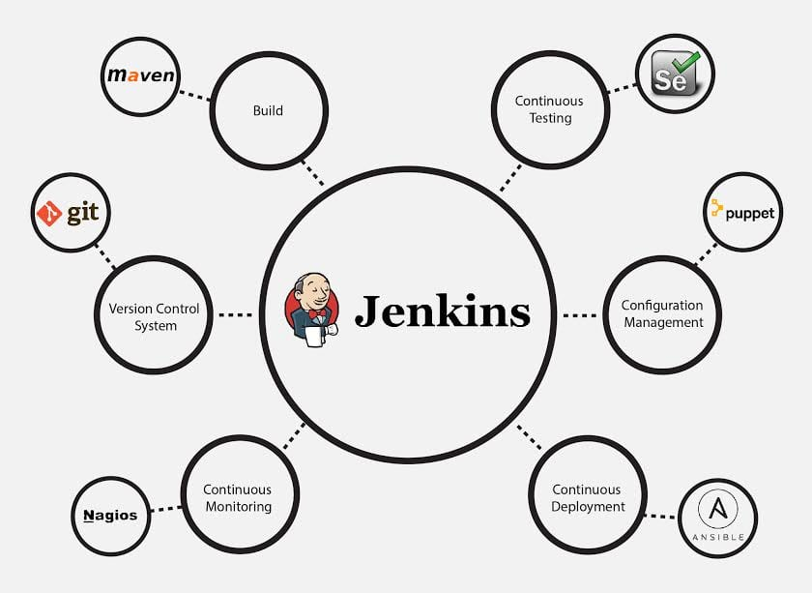

1. JENKINS BACKUP JOB Configuration

It is very important to have Jenkins backup with its data and configurations. It includes, job configs, Sectrs, plugins, plugin configuration etc.

You can download the complete code from AIE Gerrit repository as specified in below repository.

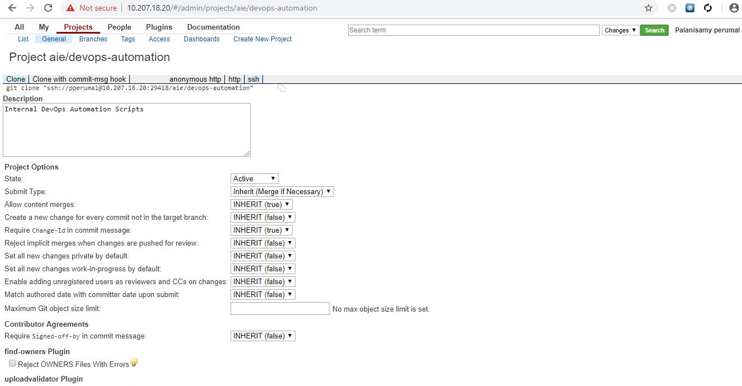

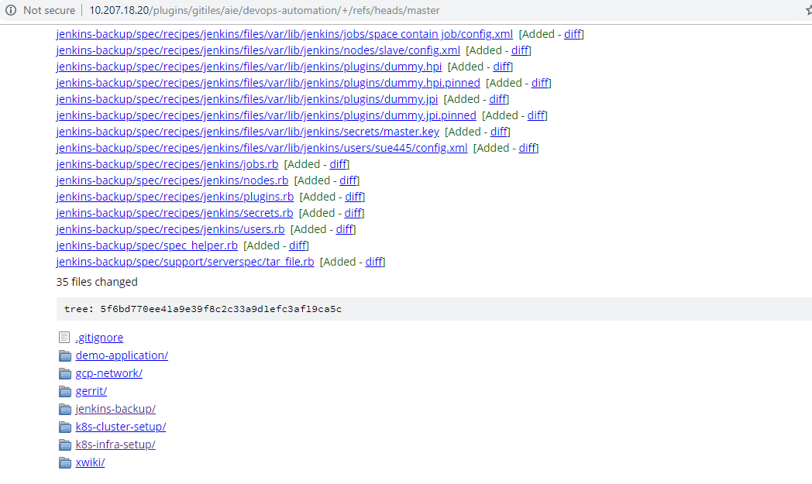

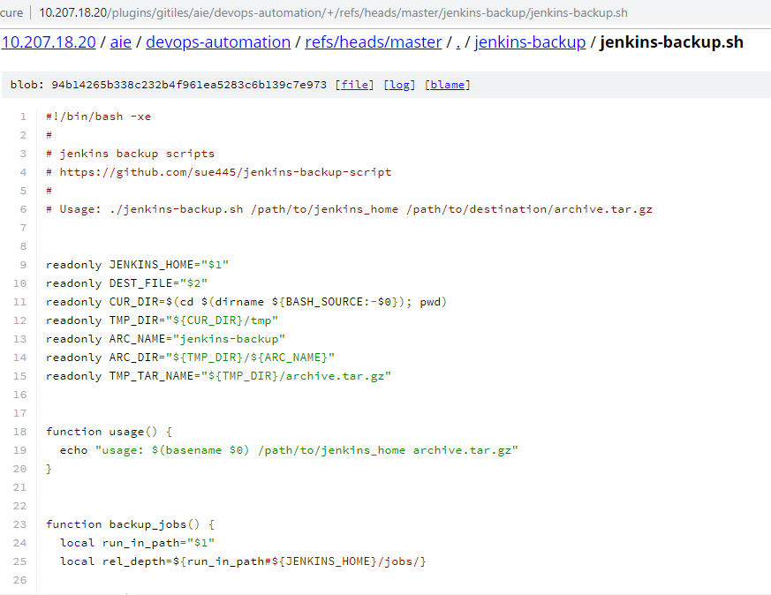

Jenkins job url: <http://10.207.18.36:8081/job/jenkins-backup/>

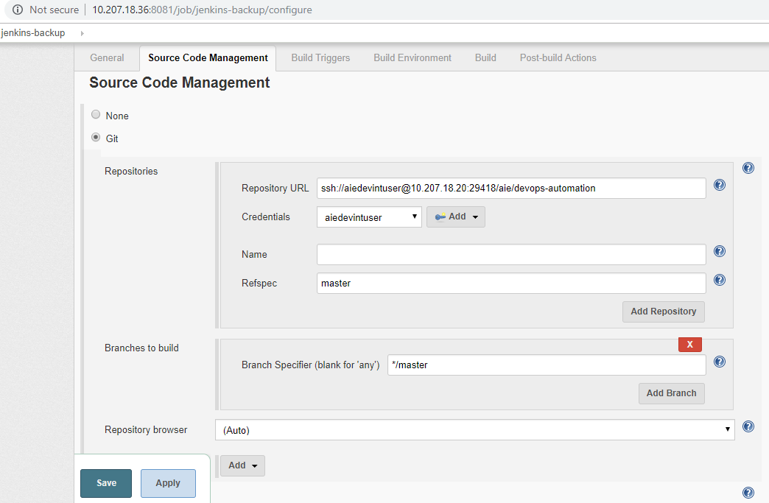

During this job execution, Jenkins will pull the code from gerrit repository and execute the shell script.

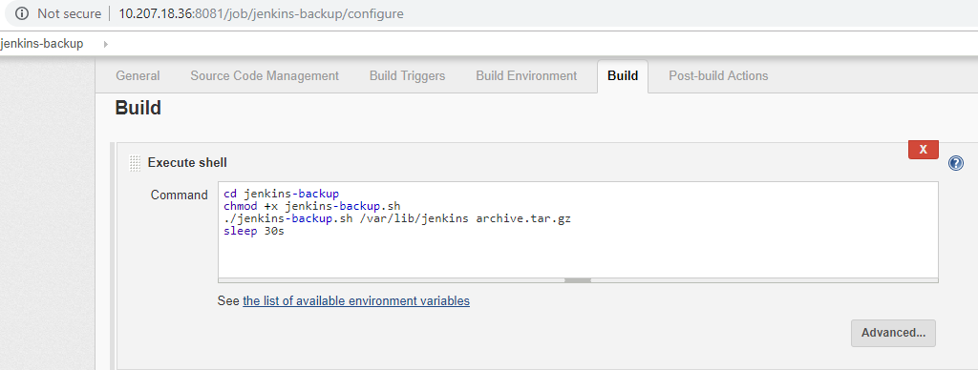

This script will Archive Jenkins settings and plugins etc

* $JENKINS_HOME/*.xml
* $JENKINS_HOME/jobs/*/*.xml
* $JENKINS_HOME/nodes/*
* $JENKINS_HOME/plugins/*.jpi
* $JENKINS_HOME/secrets/*
* $JENKINS_HOME/users/*

Once backup created in Jenkins upon completion Jenkins job execution, this will push to GCP bucket “gs://cloudops-jenkins-backup”

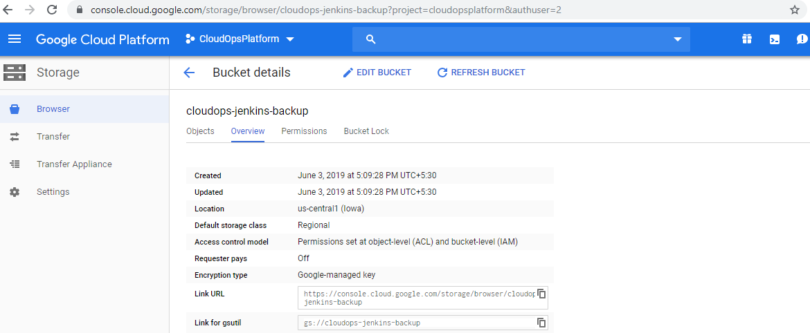

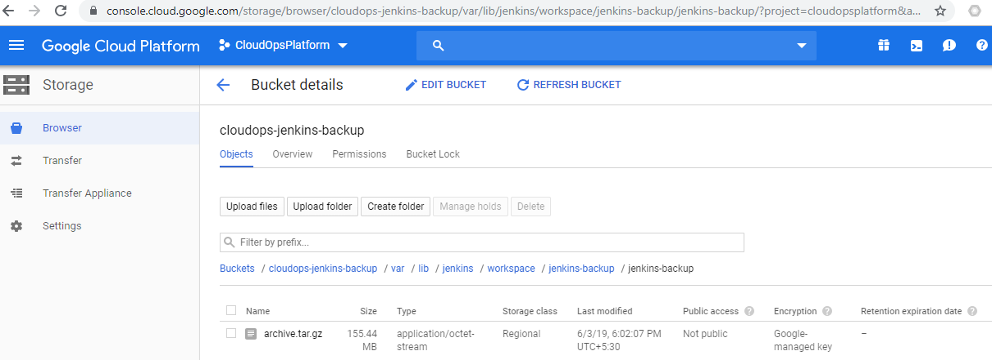

1. JENKINS Restore backup

In case if Jenkins crashed or need to restore previous state then you can perform following task in New Jenkins server. This will bring back our all existing configurations including custom themes, Jobs, secrets, plugins etc.

* sudo /etc/init.d/jenkins stop
* gsutil gs://cloudops-jenkins-backup
* cd /path/to/backup_dir
* tar xzvf backup.tar.gz
* sudo cp -R jenkins-backup/* /path/to/jenkins/
* sudo chown jenkins:jenkins -R /path/to/jenkins/
* sudo /etc/init.d/jenkins start